Homework
Year 4
Date: 17/1/2020
Reading | Spelling | Maths  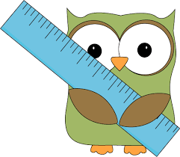
- This week, your comprehension focuses on narrative poetry.  By doing this homework, you will learn about poems that tell stories.  Complete “Narrative Poetry” comprehension.  - Remember to read regularly and to bring in your reading book every day. | The /g/ sound spelt gu  guess  guide  misguided  guitar  guard  guest  guardian  guarantee  Test date: Friday 24th January | - This relates to todays lesson on factors.  In your maths practice book, please complete:  Page 23, Pairs of Factors  Hand in for marking by Friday 24th January  - You will have a times tables test on Tuesday to test the table you need to practise.  Times Table Rock Stars has now been updated to  Give you the tables you personally need to practise.  Regular practice at home is essential.  We will monitor how often you are logging in. We can see that some people have not used it for a long time!

