Homework
Year 4
Date: 31/1/2020
Reading | Spelling  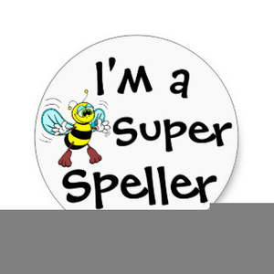 | Maths  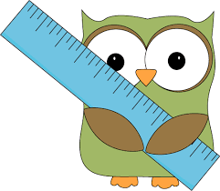
- This week, your comprehension is a progress test based on The Owl and the Pussy Cat by Edward Lear.  By doing this homework, you will will check what you have learnt about poetry from the last few comprehensions.  Complete “Forms of Poetry” comprehension.  - Remember to read regularly and to bring in your reading book every day. | Spelling focus: Spelling focus: Possessive apostrophe with plurals  See the second page of this for an easy flowchart that shows you how to use the possessive apostrophe – singular or plural, it’s the same rule.  Test date: Friday 7th February | - Practise your times tables!!  - This relates to our work on division.  In your maths practice book, please complete:  Page 25, written division.  Hand in for marking by Friday 7th February  - You will have a times tables test every Tuesday to test the table you need to practise.  Times Table Rock Stars has now been updated to  Give you the tables you personally need to practise.  Regular practice at home is essential.  We will monitor how often you are logging in.

A guide to the possessive apostrophe.
First, think about which noun is doing the owning.
Here are two dogs that own the same kennel together.
The plural noun that owns something is DOGS
Now follow this flowchart:

Does the noun ends in S?

No
Yes

Add an apostrophe and an S
Add an apostrophe

So let’s see what happens.
2 dogs own a kennel – the noun is dogs.
Does it end in s? Yes.
Just add an apostrophe: The dogs’ kennel.

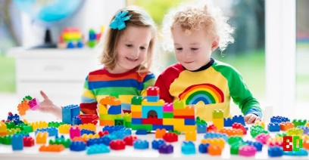
Now try this one.
These children own the lego together.
The plural noun doing the owning is children.
Now follow the flow chart.

Children own some lego.
Does the owning noun end in s? No.
Add an apostrophe then an s: The children’s lego.

The flowchart works for all nouns owning something – not just plurals.
The coat belonging to James is James’ coat, but the coat belonging to Peter is Peter’s coat.

Be careful:
Possessive pronouns never need an apostrophe. Theirs, yours, hers, his and its.
It’s always means it is.

