Homework
Year 4
Date: 28/2/2020
Reading | Spelling  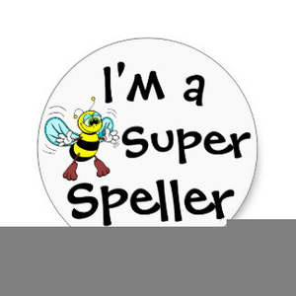 | Maths  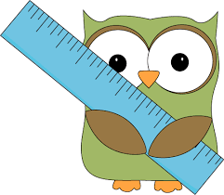
- This week, your comprehension is about the language of non-fiction texts..  By doing this homework, you will learn about how non-fiction texts will contain subject-specific words. This text is all about penguins.  Complete “The Language of Non-Fiction Texts” comprehension.  - Remember to read regularly and to bring in your reading book every day. | Spelling focus: : Homophones  Still the same words – we haven’t had a Friday to test them! New words this week.  The children will need to know the meaning of the word too, so that they can use it correctly in a sentence.  Break  Brake  Accept  Except  Aloud  Allowed  Threw  Through  Test date: Friday 6th March | - This relates to our recent work on multiplication and division.  In your maths practice book, please complete:  Page 27, Word Questions.  Hand in for marking by Friday 6th March.  - You will have a times tables test every Tuesday.  You need to be in the Garage on the Teacher Set section and also in the soundcheck.  We will monitor how often you are logging in.

