Homework
Year 4
Date: 18/10/2019
Reading | Spelling  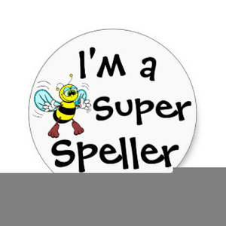 | Maths  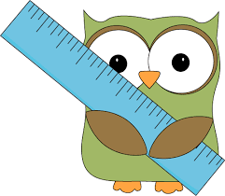
- This week, your comprehension focuses on the themes of legends.  By doing this homework, you will learn about why we have legends and typical features you would find in a legend.  Complete “Themes of Legends” comprehension.  - Remember to read regularly and to bring in your reading book everyday. | Homophones  mane/main  peace/piece  fare/fair  it’s (it is)/its (possessive pronoun)  Test date: Friday 27th October | - This relates to our current topic of addition and subtraction.  Please complete pages 13 and 14 of your maths practice book.  It is worth checking that your children know their number bonds to 20 and can recall them at speed.  Hand in for marking by Friday 27th October.  - Don’t forget to use your TT Rockstars login to practise your times tables at least 3 times a week. Go into the garage and sound check areas. The class practice average is currently only 1min 12 seconds a day!

