Year Planner
The plan below briefly outlines the topics the children will cover. Occasionally, some elements won’t be covered during the term indicated but will have been studied by the end of the year.
Throughout the year, themes will be revisited in both English and Maths in order to further consolidate skills and understanding. Wherever possible, other subjects will use the skills that have been taught in Maths and English lessons.

 | Autumn | Spring | Summer
English | Each week, the children will focus on an element of grammar as well as a particular style of writing, e.g. journalistic writing, information texts, poetry, biographies. The different forms of writing will be revisited throughout the year, with the children applying their skills to written work that is linked to their termly topics.
 | SPaG objectives are covered continuously across all three terms. Previously taught genres are also revisited across the curriculum.
Maths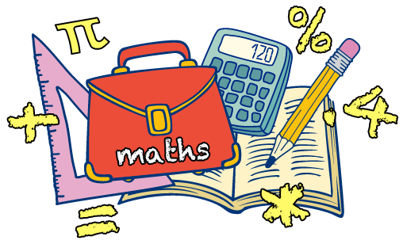 | Number and Place Value;  Addition, subtraction, multiplication and division;  Fractions. | Decimals;  Percentages;  Measurement;  Algebra;  Ratio;  Geometry;  Statistics. | Geometry – properties of shape;  Geometry – position and direction.  Post SATs project work to ensure readiness for secondary school.
Science | Classification of living things.  Electricity | Light  Circulation | Evolution and Inheritance
Computing | E Safety;  Control and programming;  Research;  Multimedia. | Databases and spread sheets;  Data logging;  Research;  Multimedia. | Databases and spread sheets;  Control and programming;  Research;  Multimedia.
History /  Geography/  Art/  DT | World War II – A turning point in British History. Including a local study.  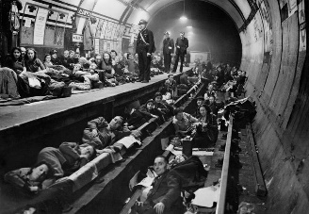 | The Ancient Egyptians – an early civilisation  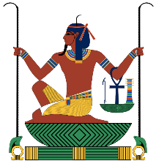 | Comparative studies (including Africa though links developed in class.)  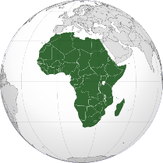
If you have any questions regarding how to support your child at home then please do not hesitate to contact me.

