Homework
Year 4
Date: 8/11/2019
Reading | Spelling | Maths  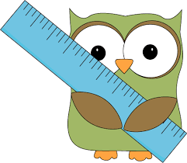
- This week, your comprehension focuses on the Complex Characters.  By doing this homework, you will learn about good and badrole models in stories.  Complete “Complex Characters” comprehension.  - Remember to read regularly and to bring in your reading book everyday. | Yr 3 and 4 spelling list  February  forward(s)  fruit  grammar  group  guard  guide  heard  Test date: Friday 15th November | - This relates to our current topic of addition and subtraction.  Please complete pages 15 and 16 of your maths practice book.  Hand in for marking by Friday 15th November.  - Don’t forget to use your TT Rockstars login to practise your times tables at least 3 times a week. Go into the garage and sound check areas. The class practice average is currently only 1min 12 seconds a day!

