Week | News story | Focus question | UN Article | British value
12th  April | The Royal Voluntary Service (RVS) has recently marked one year since the NHS Volunteer Responders scheme launched. | Should everyone volunteer in their spare time? | 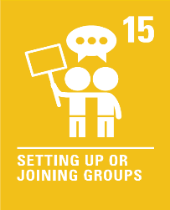 | Mutual Respect - We can choose to volunteer or raise funds. This might be at our school or in the community. Volunteering can benefit others and can also make us happy.
19th  April | The Union Jack will be flown on UK Government buildings every day of the year under plans to celebrate the United Kingdom’s heritage and pride. | Should we be allowed to fly flags anywhere? | 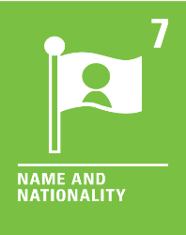 | Rule of Law - The Union flag is the national flag of the United Kingdom of Great Britain and Northern Ireland. From this Summer, the Union flag must be flown every day on UK government buildings as a symbol of UK’s national unity and pride.
26th  April | Children's Laureate, Cressida Cowell, has written a letter asking the prime minister to allocate £100m a year to help school libraries. | Should all schools have a library? | 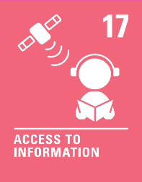 | Democracy - We can get lost in a book in a school library! Reading for pleasure can help us become better citizens, even helping us decide how to vote.
3rd  May | The retailer Marks and Spencer (M&S) has begun legal action against supermarket Aldi, arguing the supermarket's Cuthbert the Caterpillar cake infringes its Colin the Caterpillar trademark. | Is it always wrong to copy others? | 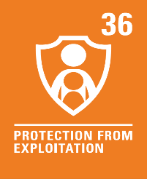 | Mutual Respect and Tolerance - It is important to respect other people’s feelings and check if it’s OK before we copy someone. Some people may not mind if we copy what they do or say, but others may get upset.
10th  May | Within days of the announcement of a new football Super League competition - open to only the biggest clubs, most of the teams had withdrawn, deciding they no longer wanted to take part. | What role does sport play in our lives? | 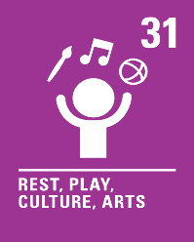 | Individual Liberty - In sport, we can decide whether we want to take part in teams and competitions or not. If we do, it is important to consider the effect our decisions will have on the other participants.
17th  May | Sing2G7, an ambitious project aiming to give children a voice ahead of the upcoming G7 Summit, have recorded a song at Truro cathedral. | Does music have the power to change our behaviour? | 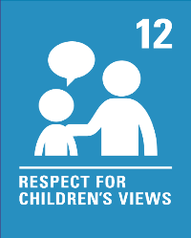 | Democracy - People sometimes sing songs to make their voices heard or to encourage others to think about an important issue such as climate change.
24th  May | The newest toy craze sweeping schools called Pop-Its has replaced the fidget spinner as the must-have item in the hands of both young and old. | Is there a place for sensory toys in the classroom? | 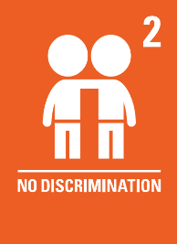 | Mutual Respect and Tolerance - Everyone’s sensory needs are different. Some people may need sensory toys to help them when they are anxious, but other people may not. Every person needs to be treated as an individual.

