Week | News Story | Focus Question | UN Article | British Value
7th  June | The government is trying to encourage greener farming methods and believes that the next generation of farmers will be best equipped to make these changes. | How important is the role of farmers? | 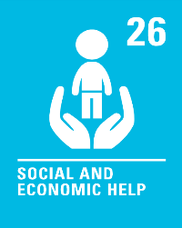 | Individual Liberty - There are lots of different jobs that we can choose to do when we leave school. The types of jobs people do might change over time. Sometimes employees, like older farmers, are offered money to persuade them to find a different job. Older farmers can choose to stay in the job or take the money and leave farming.
14th  June | The world number two female tennis player Naomi Osaka has withdrawn from the French Open tennis tournament after the controversy over her refusal to speak to the media at the tournament. | Should sports stars be expected to give interviews? | 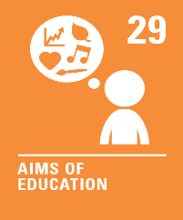 | Mutual Respect and Tolerance - Some people have more confidence to speak in public than others. It is helpful to work as a team and give others our support if some of our classmates find it more difficult.
21st  June | The electric scooters, also known as e-scooters, are now available to rent in selected areas of London as part of a one-year scheme to measure their feasibility. | Should e-scooters be allowed on our roads? | 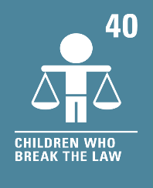 | Rule of Law - There are laws in place so that people use e-scooters safely. If e-scooters become more popular in the future, laws may have to change to protect members of the public.
28th  June | Players, teams and fans have sent messages of support to Christian Eriksen after the football player collapsed just before half-time in Denmark's opening Euro 2020 game. | What life skills should we learn at school? | 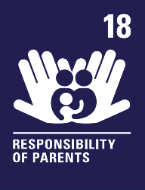 | Individual Liberty - Learning new life skills helps us to make better choices about how we live our lives and how we manage risk.
5th  July | UNESCO (the United Nations cultural body) has said that the Great Barrier Reef in Australia should be put on a list of World Heritage Sites that are ‘in danger’ due to damage caused by climate change. | Are some places around the world more important than others? | 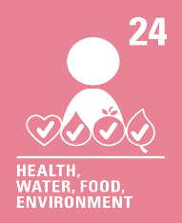 | Mutual Respect - Climate change is causing our oceans to get warmer. We can all help to protect the special places in our world.
12th  July | New research has shown that fewer than 1% of authors that feature in exam texts in English secondary schools are from an ethnic minority background. | Are we all reflected in the books we read? | 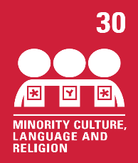 | Mutual Respect and Tolerance - Reading books from a diverse range of authors helps us to understand that life is not the same for everyone. We can learn to respect people’s different cultures, faiths and beliefs from books.
19th  July | The world's largest ever trial of a four-day working week and reduced working time has been described as an "overwhelming success" following a 5-year pilot held in Iceland. | Would we all work better with a four-day week? | 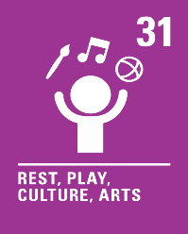 | Individual Liberty - A four-day working week may give people more responsibility for organising their own work and leisure time. Workers may also have more choice about how they create a healthy work/life balance.

