Homework
Year 4
Date: 24/1/2020
Reading | Spelling | Maths  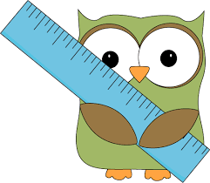
- This week, your comprehension focuses on forms of poetry.  By doing this homework, you will learn that poems have different strucures.  Complete “Forms of Poetry” comprehension.  - Remember to read regularly and to bring in your reading book every day. | Spelling focus: -ture words  mixture  adventure  capture  feature  moisture  nature  picture  temperature  Test date: Friday 31st January | - Practise your times tables!!  - This relates to our work on multiplication.  In your maths practice book, please complete:  Page 20, The Times Tables  Hand in for marking by Friday 31st January  - You will have a times tables test on Tuesday to test the table you need to practise.  Times Table Rock Stars has now been updated to  Give you the tables you personally need to practise.  Regular practice at home is essential.  We will monitor how often you are logging in. We can see that some people have not used it for a long time!

