Week | News Story | Focus Question | UN Article | British Value Link
30th  May | The Indian city of Delhi is experiencing its fifth heatwave since March, with temperatures hitting a record 49.2 degrees Celsius in places. | How does the weather affect our daily lives? | 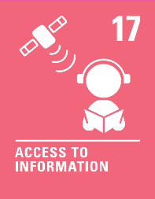 | Rule of Law - Severe weather conditions may see new rules or guidance introduced. These are put in place to help protect us and keep us safe.
6th  June | Wales' Chief nursing officer, Sue Tranka, has said that depicting nurses as superheroes has placed added pressure on already exhausted workers. | Can anyone be a hero? | 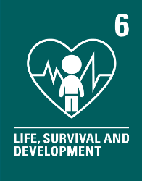 | Mutual Respect - Our behaviour, actions and  words affect others. We all have the power to change people’s lives for the better. We can all be heroes!
13th  June | FIFA (International Federation of Association Football) has announced three female referees will officiate at the men’s World Cup tournament for the first time ever later this year in Qatar. | Does sport have a part to play in making the world a fairer place? | 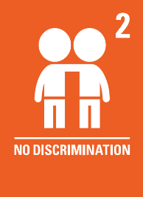 | Rule of Law - Referees enforce the rules of the game, which helps make it fair and safe. If players do not follow the rules, there can be consequences and they may even be asked to stop playing.
20th  June | The technology company, Google, has recently announced changes to its search engine, including the introduction of the ‘Monk Skin Tone Scale’ to help make search results more inclusive by showing a wider range of skin tones. | How can we make sure that everyone is included? |  | Mutual Respect - Not everyone is the same as me  and their lives can be very different from mine. If we all try to understand one another, we can help to make sure we all feel included.
27th  June | A new study, from the University of Montpellier in France, has found that less attractive species of fish are more likely to be threatened with extinction than their more attractive counterparts as they lack public support. | How important are appearances? | 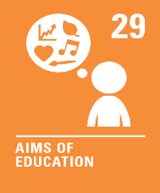 | Individual Liberty - Research has shown that some  species of fish are more likely to be threatened with extinction as they lack public support. It is important  to remember our actions have consequences and we are responsible for them.
4th  July | Requests to join the Scouts and Girlguiding groups have reached the highest levels for over 80 years. The Scout Association said nearly 90,000 young people across the UK are currently on waiting lists and Girlguiding has nearly 55,000 people waiting for a place. | Is it important for everyone to have a hobby? | 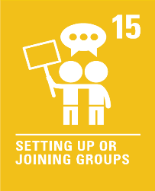 | Individual Liberty - We all have the right to choose  our hobbies. Some of our hobbies may even have a positive impact on others and our world.
11th  July | An island of wet wipes has 'changed the course of the Thames’ river in London. The island, thought to be around the size of two tennis courts, has prompted many campaigners to fight for them to be banned. | Should wet wipes be banned? |  | Rule of Law - Sometimes items can be banned. This means a rule or law is put in place to forbid this item being used. It is important to remember that rules and laws are there to protect us.
18th  July | A recent study, conducted by the British Medical Journal (BMJ), has found that trampolining is to blame for half  of all activity-related UK Accident and Emergency (A&E) hospital admissions in under-14s. | Should there be more rules for trampolines? | 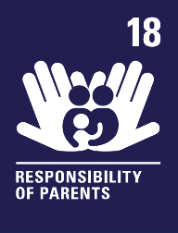 | Rule of Law - Places, like trampoline parks, have rules and adults in our home or at school may also set rules.  We are all responsible for following these rules and keeping ourselves and others safe.

