Homework
Year 4
Date:25/10/2019
Reading | Spelling  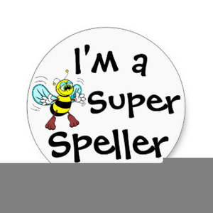 | Maths  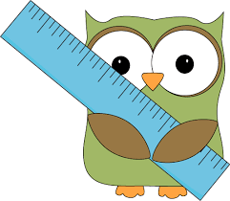
Read a good book and talk about it.  - Remember to read regularly and to bring in your reading book everyday. | Year 3 and 4 spelling words:  eight/eighth  enough  exercise  experience  experiment  extreme  famous  favourite | - Have a go on TTRockstars to keep your knowledge ticking over.

Have a good rest everybody!

