 | Autumn | Spring | Summer
Themes | WE ARE BRITAIN!  (history focus) | WE ARE WIRRAL!  (geography focus)  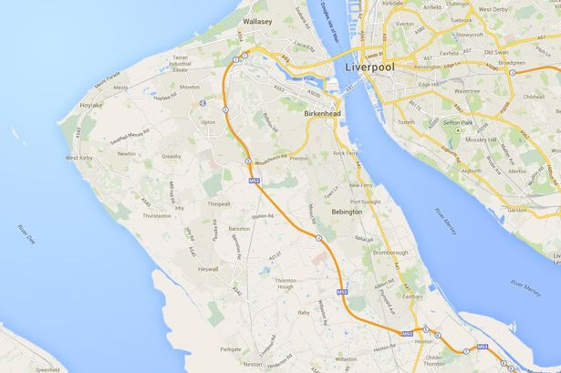 | WE ARE EXPLORERS!  (science focus)
English

 | Stories in familiar settings – Adventure are the Pits | Stories with historical settings - Shirley Hughes  Instructions – link with Fun Food Chef | Traditional tales from other cultures  Adventure stores - Way Back Home
 | Recounts – Great Fire | Humorous poems  Information text – local study | Letters and postcards  Shape poems
 | Poetry – Wilfred Owens
 | Christmas Stories
Maths | Place value and number | Measurement - money | Measurement – time  Measurement – capacity and volume
 | Addition and subtraction | Geometry – properties of shape | Geometry – position and direction
 | Measurement – length and mass | Multiplication and division | Addition and subtraction
 | Statistics - graphs | Place Value and number
 | Multiplication and division
 | (See additional maths plan)
Science | Everyday materials  Compare how things move on different surfaces | Animals, including humans  Living things and their habitats - Chester Zoo visit | Plants
 |  |  | Space
Geography | Walk to Fire station  Exploring our country – cities  Weather in the UK | Local study – Travelling Ted  Using aerial images to create plans/maps  Comparing with a non-European country (link with non-European country) | Exploring a far away place – Asia  Oceans and seas  Weather around the world  Space stations
History | Great Fire  Remembrance day and Florence Nightingale | Family history  Mary Seacole | Christopher Columbus  Neil Armstrong
Art | Self Portraits | Ian Fennelly | Space style art – Annette Cook
 | Lowry
DT | Model making of London  Design and make a fire engine | Make a lighthouse  Grow cress and make egg and cress sandwiches | Fun Food Chef  Make a moving picture of outer space
Music |  | Charanga | War of the worlds
 | Christmas Songs & Production
RE |  |  | Hinduism
 | Rules and routines  Christianity – the nativity | Christianity - Easter
PE | Invasion Games | Net Games | Invasion Games
 | Gymnastics | Dance | Athletics
Computing | E safety  Multimedia | Programming  Communication-Word Processing | Handling Data  Research
Celebration | Christmas | Easter
Gayton Primary School
Curriculum Theme Plan 2018/2019
Year 2

