Homework
Year 4
Date: 04/10/2019
Reading | Spelling  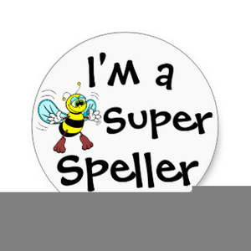 | Maths
This week, your comprehension focuses on words in context.  By doing this homework, you will learn about how authors choose their words carefully to make an impact on their reader –and how the context of the word matters.  Complete the “Words in context” comprehension. | Words from the year 3 and 4 word lists.  accidental (ly)  appear  arrive  build  certain  circle  complete  consider  Test date: Friday 11th October | We’ve been looking at place value.  Please complete pages 7 and 8 of your maths practice book.  Hand in for marking by Friday 11th October.

