Week | News story | Focus question | UN Article | British Value Link
30th  August | The Tokyo Olympic Games saw four new sports added to the competitive landscape, karate, skateboarding, sport climbing and surfing. | What makes a good Olympic sport? | 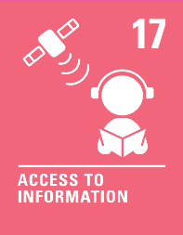 | Democracy - Four brand-new events were added to this year’s Olympics. Each member of the International Olympic Committee (IOC) voted to decide which events should be included.
6th  September | Over the past two weeks the Paralympics have taken place in Tokyo, following the postponed 2020 Olympics. | Can the Paralympics help us become more inclusive of others? | 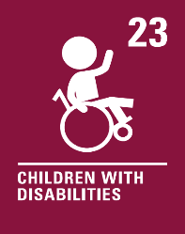 | Mutual Respect - We know that life is not always the same for everybody. The Paralympics is an event for people who have a disability to compete in sports and become champions!
13th  September | The people in Afghanistan are now under Taliban leadership following the collapse of the country's government, the UK has introduced a new resettlement scheme for Afghan refugees, aimed at helping those most in need. | How would you feel if you were forced to leave your home? | 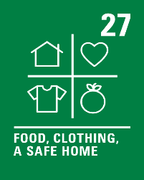 | Individual Liberty - We all have the right to live somewhere safe. We can choose to help refugees, who have had to leave their country, homes and lives behind them.
20th  September | Following the trail of devastation left by Hurricane Ida across parts of North America, US President Biden has blamed climate change for what’s happened and believes the country needs to be better prepared for extreme weather. | How does facing disasters change us? | 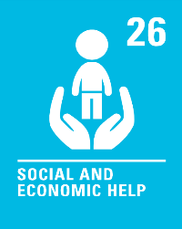 | Rule of Law - Governments have safety rules and laws in place to reduce the risk of disasters occurring. Sometimes a natural disaster is beyond our control. It is how we respond during and afterwards that is important.
27th  September | It is estimated that people in Britain are sending over 1.6 billion non-biodegradable face masks to landfill every single month, according to research conducted by shopping comparison site, finder.com | Should disposable face masks be banned? | 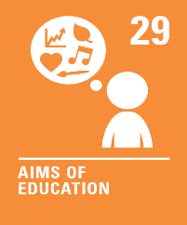 | Individual Liberty - We can choose whether to use reusable or disposable items such as face masks. It is important to consider a number of factors, including the environment, when we make our choices.
4th  October | Encouraging people to use buses more often is to be a central part of the Government’s plan to reach net zero by 2050. | What would encourage you to use public transport? | 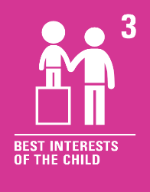 | Democracy - People aged 18 or over vote for who they want to govern our country. Our Government makes decisions for the country. Mobility hubs form part of the Government’s plan to reach net zero by 2050.
11th  October | Children’s TV channel CBeebies has hired George Webster as its first ever presenter with Down’s syndrome. | What does a good role model look like? | 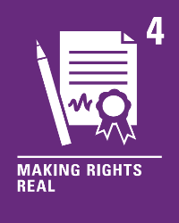 | Tolerance - We all have different opinions, beliefs and values so our role models will be different too. Being tolerant of our differences means people feel accepted and free to be who they want to be.
18th October | This year’s Nobel Prize winners have been announced and include two American scientists, who discovered how we feel physical pain and pleasure, winning the 2021 Nobel Prize for medicine. | Is it important for all our achievements and good deeds to be recognised? | 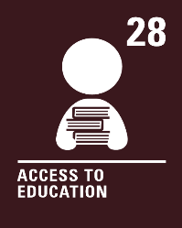 | Individual Liberty - People who win Nobel Prizes have made choices to produce work that benefits humankind. We can make choices that can benefit others too.

