
Information for Year Five Parents 2018 - 2019

Weekly timetable


Maths and English are usually taught every day. As part of our creative curriculum, other subjects are often closely linked to topic work and are not taught on specific days although most are taught each week; occasionally a subject may be a project focus for a week, e.g. art or design and technology. All curriculum areas will have received full coverage by the end of the academic year. Children have PE on a Wednesday and can come to school in their school t-shirts, joggers and sweatshirts.

Year Planner

The plan below briefly outlines the topics the children will study. Throughout the year, themes will be revisited in both English and Maths in order to further consolidate skills and understanding. Wherever possible, the skills that have been taught in Maths and English lessons will be applied in other subjects.

 | Term 1 | Term 2 | Term 3
English | Each week, the children will focus on an element of grammar as well as a particular style of writing, e.g. journalistic writing, information texts, poetry, biographies. The different forms of writing will be revisited throughout the year, with the children applying their skills to written work that is linked to their termly topics.
Maths |   In the autumn term the main focus will be number, including place value and all four number operations. | The spring term will also focus mainly on number and will include work on fractions, decimals and percentages. | In the summer term the children will apply number skills within other areas of maths such as geometry and measurement.
Science | - Living things and their habitats  - Properties and changes of materials | - Living things and their habitats  - Forces  - Earth and Space | - Living things and their habitats  - Animals including humans
Science | The children will develop their skills of working scientifically throughout all science topics.
ICT | - Research  - Text processing and multimedia  - Data logging  - E-safety  - Programming | - Research  - Text processing and multimedia  - Spread sheets  - E-safety  - Programming | - Research  - Text processing and multimedia  - E-safety  - Programming
Project focus for Foundation Subjects | The Mysteries of Harris Burdick   | The Americas  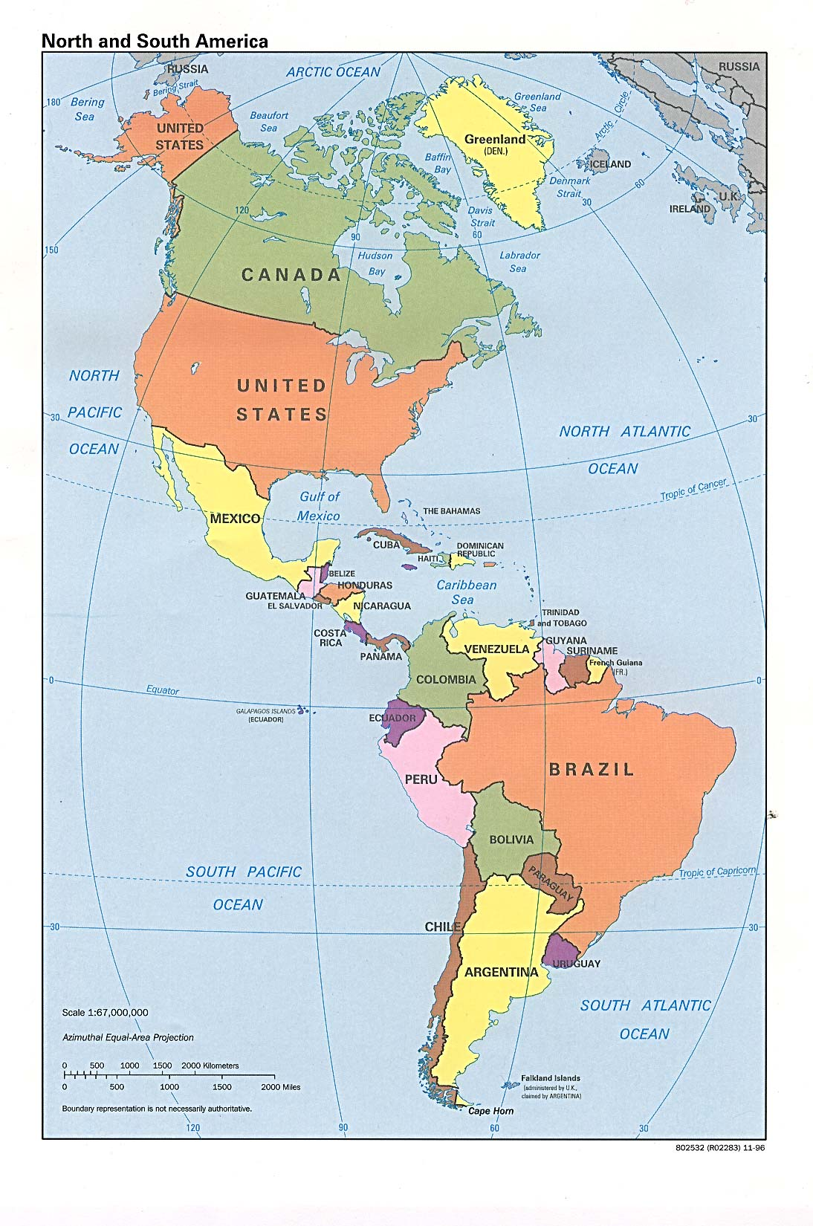 | The Victorians  

