Week | News story | Focus question | UN Article | British value
25th October | One of Scotland’s most influential football players of all time is likely to be one you’ve never heard of. Andrew Watson captained Scotland to a 6-1 win over England on his debut in 1881. | Who should decide the parts of history we choose to remember? | 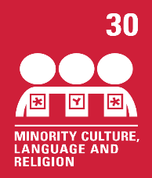 | Mutual Respect - We can learn about other people’s lives in the past: their achievements, cultures, beliefs and how they shaped the world today. It is exciting to learn from so many different people.
1st November | The COP26 climate summit, one of the biggest ever world meetings on how to tackle climate change, is taking place between 31st October and 12th November 2021 and is being held in Glasgow. | What are the best ways to tackle climate change? | 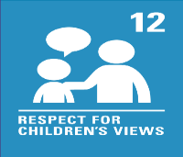 | Rule of Law - Most countries have rules and laws that have been put in place to tackle climate change. The COP26 climate summit brings world leaders together as although their rules and laws may vary, their aim is the same.
8th November | A new study published in Science magazine found that in Gorongosa National Park, Mozambique, a rare genetic condition, that causes tuskless elephants, has become more common. | Should we do more to protect elephants? | 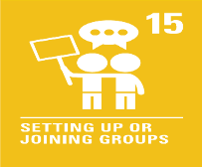 | Individual Liberty - It is important to remember our actions may have consequences. The actions of poachers have caused an increasing number of elephants being born without tusks.
15th November | A German professor believes that secure playgrounds prevent young people from finding out important dangers during their early years. | Do we need to experience danger to learn how to be safe? | 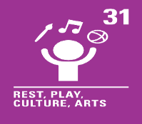 | Individual Liberty - As well as being fun, playgrounds can be a great place for us to learn. We can learn to manage risks and take responsibility for our actions.
22nd November | Travel company, Expedia, has banned the sale of holidays involving dolphins and whales. | Should we be allowed to swim with dolphins? |  | Democracy - Travel company, Expedia, has banned the sale of holidays involving dolphins or whales. Some people may agree with this; others may not. We all have a voice, we can share our opinions and we can listen to the opinion of others.
29th November | Brazil's indigenous people came together at COP26 earlier this month to share their message, that the world needs their expertise in protecting the Amazon rainforest. | Is the world a better place when we live a more natural life? |  | Mutual Respect - The Munduruku are indigenous people, who live in parts of Brazil. Their life is different from ours but we understand and respect that.
6th December | Facebook founder, Mark Zuckerberg has announced Meta, a new company brand for Facebook apps and technologies. | Do we need to create a virtual universe? | 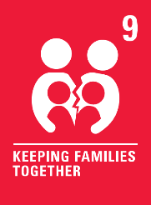 | Tolerance - People have different ideas and opinions of how virtual reality could impact our world. It is important to tolerate and accept these ideas and opinions even if they differ from our own.
13th December | School nativity plays and musical concerts have taken place in various formats this year, with some schools hosting events entirely online, others taking a hybrid approach and some even opting for performances outdoors. | Who are school performances for? | 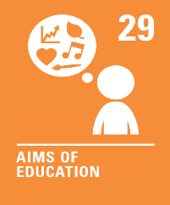 | Rule of Law - Laws, rules or guidance sometimes change to help keep us safe so we may have to alter the way we do things. We can adapt the way we perform our school plays and concerts this year so they can still go ahead.

