Week | News story | Focus question | UN Article | British value
18th  April | Machu Picchu in Peru, South America, is believed  to be one of the world’s best-known archaeological sites, attracting hundreds of thousands of visitors a year, but according to a new study, it has been called the wrong name for more than 100 years. | Are names just a label or can they mean something more? | 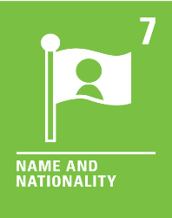 | Mutual Respect - We are all different. Our names can help  to identify us. We can use people’s names to show friendship and respect.
25th  April | Access to a new scheme offering free pet  healthcare across 38 European countries, is now available to Ukrainian refugees, who have left the country with their pets to avoid the conflict. | Should pets be protected more than other animals? | 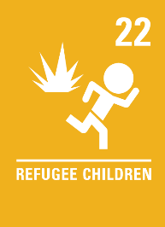 | Democracy- We all have a voice and can use it to make a difference to things we care about. Some charities and volunteers have used their voice to help protect and care for pets escaping conflict in Ukraine.
2nd  May | Chief executive of the electric car manufacturer, Tesla, and founder of SpaceX, Elon Musk, has reached a deal to buy Twitter, stating that he is the right person to release the social media platform's extraordinary potential. | Should we have the right to say whatever we choose? | 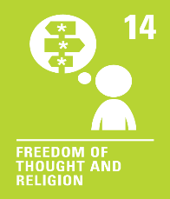 | Individual Liberty - We all have rights and freedoms. We can choose how we speak, think and act. It is important to remember to take responsibility for our choices and the consequences they may have.
9th  May | Danielle Webb, who is 23 and lives with dwarfism, recently wrote a book and regularly visits schools  to help educate others about her condition in a bid to stamp out prejudice. | What makes us unique? | 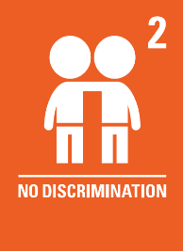 | Democracy - Danielle has used her voice to help educate others and stamp out prejudice. It is important that we listen so we can understand, learn about, and celebrate our differences.
16th  May | Cereal company, Kellogg's, is taking the UK government  to court over new rules that would stop some of its cereals being put at the forefront of supermarket shelves, as they have high amounts of sugar. | Should you always be allowed to choose your own breakfast? | 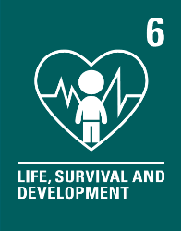 | Rule of law - Rules and laws are put in place  to protect us. The government’s new rules, that restrict the promotion of food and drink that is high in fat, salt and sugar, aim to encourage people to make healthier food choices.
23rd  May | Buckingham Palace has unveiled the full line-up of celebrations to mark the Queen's Platinum Jubilee this year. | How important is it for us to have a sense of duty? | 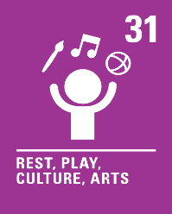 | Individual Liberty - Everyone has their own responsibilities and duties. Part of these are how we choose to behave and act. We are all responsible for our own actions.

