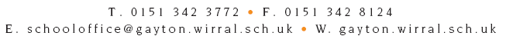
Headteacher: Mrs J McAleny

September 2019

Dear Parents/Carers,
We would like to obtain your permission for your child to participate in local trips within the Heswall and Parkgate area, including walking on the Wirral Way, visits to other local Schools, Churches and the Fire Station.
We will notify you in advance of the day and time of any trips planned.
If you are happy for your child to participate, please sign and return the attached Consent. The Consent is intended to run for the entirety of their time at Gayton Primary School. Therefore, if you wish to withdraw consent at any time, please contact us in writing to advise accordingly.
Yours sincerely

Mrs J McAleny
Headteacher

…………………………………………………………………………………..………………………………………………………………………………..

Gayton Primary School – Local Trips Consent Form

I give permission for my child (name)…………………………………….……………………Class……………………………..……..

To participate in any local trips/visits within the Heswall and Parkgate area. I understand this authority will continue for their time at Gayton Primary School.

Signed……………………………………………….………………..Parent/Carer Date……………………………………….

